Operating Systems

Lab Report 3

(8-10)

**SUBMITTED BY:**

**SHAHZANEER AHMED**

**REGISTRATION**

**NUMBER**

**:**

**SP21**

**-**

**BCS**

**-**

**087**

**SUBMITTED TO**

**:**

**Dr. Rubina Adnan**

**DATE**

**OF**

**SUBMISSION:**

**January 5, 2022**



**LAB 08**

# **TASK 1:**

Write C++ program that declares an array of size 1000 and populates it with random numbers between 1 and 100. Then it finds factorial of these numbers and checks how many of these prime numbers are.

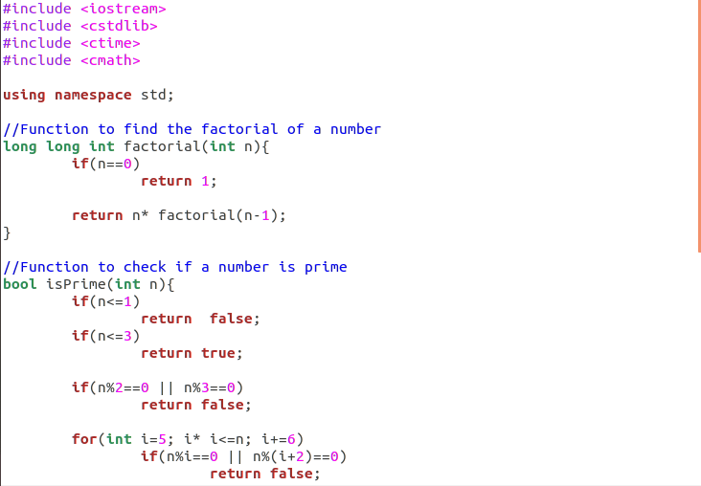

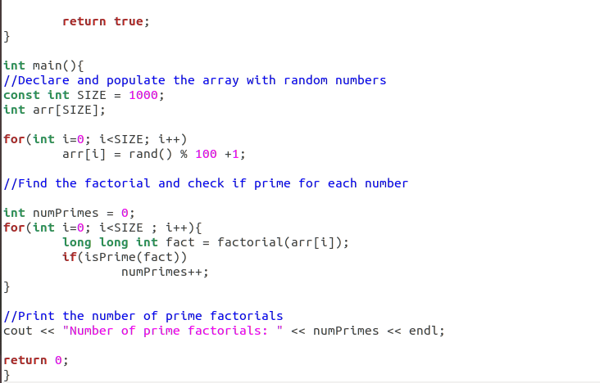





# **TASK 2:**

Now, create two thread such that the first thread process finds the factorial of these numbers (given in the above array) while the other finds how many of these are prime.

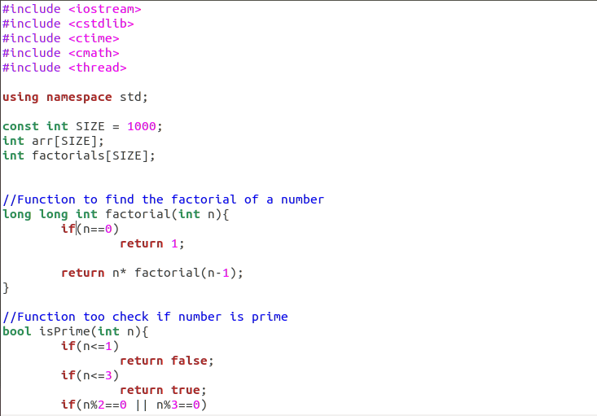

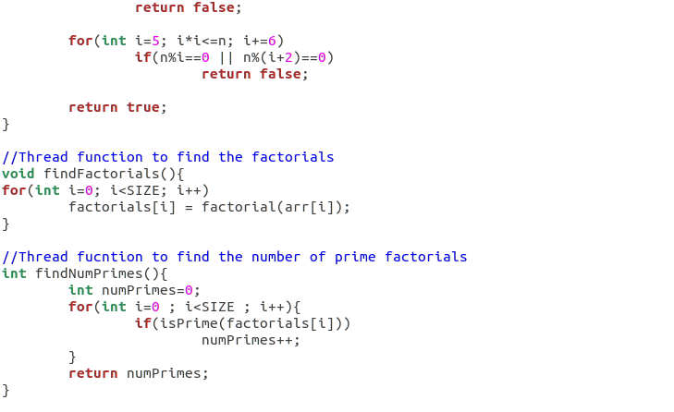

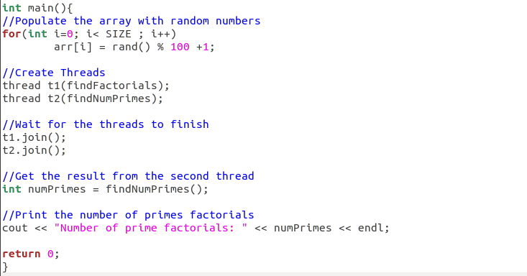





**LAB 10**

